UN SDG Goal 14: ‘Life Below Water’ is missing the fact All Life is Under ‘Living’ Water and none can live in ‘Dead Water’

David M. Boje Nov 7 2018; Revised Nov 12th

Abstract
Are you drinking living or dead water? Living water is rich in essential minerals. Often bottled water goes through reverse osmosis and is ‘dead water’ void of calcium, magnesium and other micro and macro trace minerals essential for healthy bodies. To the untrained eye polluted contaminated ‘dead water’ looks exactly like healthy energetic ‘living water.’ Water dies when big corporations get their water from the tap, truck it to a central processing facility, put it through some kind of water treatment, perhaps insert additives, and ship it as bottled water on store shelves. Tap water is already ‘dead water’ that does not hydrate or reenergize the body’s living cells vitality with minerals and nutrients. Without some concerted global action humanity and most life on earth will not survive Sixth Extinction. The UN Goal 14 ‘Life Below Water’ is a narrative that leaves out the untold story of the role of Water Capitalism in hastening and deepening the Sixth Extinction, already underway.

Which water should living beings, be drinking? Ever notice that cats refuse to drink reverse osmosis water? Fish and other animals cannot survive on reverse osmosis water that many bottled water and flavored water manufacturers are using. That is because it is ‘dead water’ Most living beings, except humans, can tell the difference between ‘living water’ and ‘dead water’ that cannot sustain life.
Rainwater is ‘living water’ and said to be cleaner and healthier than ‘dead water’ from the tap, or bottled in plastic (which FYI is mostly tap water, & carries more chemical pollutants than tap water). Carbon-filtered rainwater, with cucumbers, is my ‘living water’ of choice. I am doing rainwater harvesting. First flush of the rainwater eliminates most of the dust settling on the roofs. For drinking rainwater, I use Brita water pitcher filtration. Rainwater is pure ‘living water’ with similar pH to distilled and reverse osmosis water. Rainwater promotes detoxification, helps to neutralized blood pH, and is chlorine free (unlike tap water or bottled water), and is anti-cancer anti-oxidant. When my wife and I go to Tilos Island, we drink the spring water that flows up through an entire mountain to a monastery.
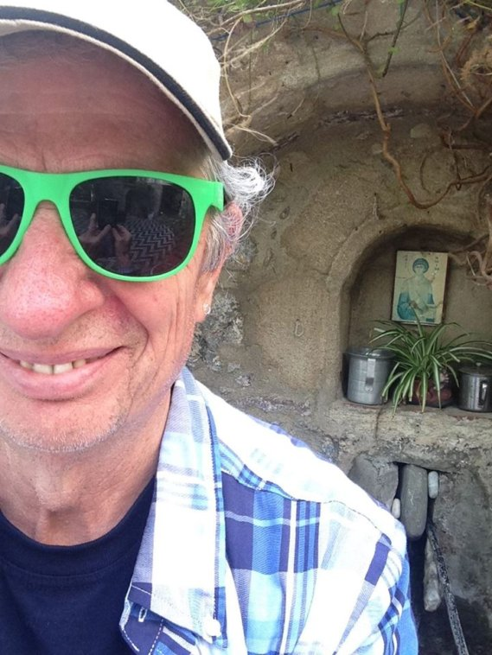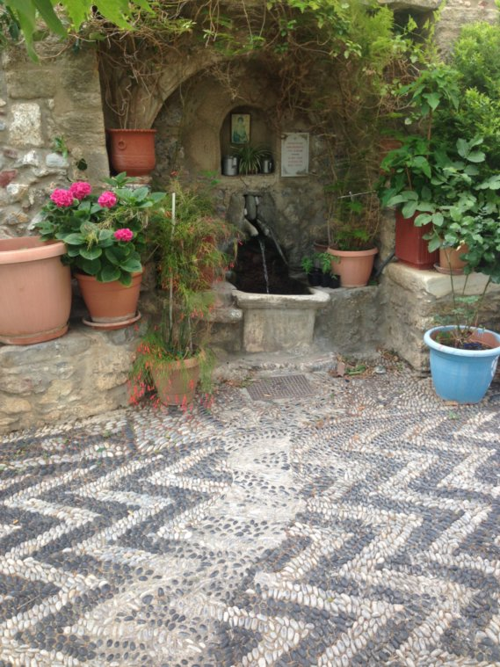
Figure 1: Boje Drawing Rainwater from Mountain Spring atop Tilos Island Monetary

Instead of high calorie soda water, or bottled water, we can begin to filter rainwater, and add minerals that give wellbeing. For example, slice a cucumber and notice how it adds to your wellbeing in ten ways:
- Cucumbers contain antioxidant-molecules that block free radicals (unpaired electrons) that have anti-cancer results.
- Cucumbers transport oxygen and are good for muscle health.
- Cucumbers flush toxins out of the body and support brain health.
- Cucumbers enhance blood pressure., cool the body, thereby reducing bad breath.
- Cucumbers help with weight loss as mild diuretic to curb appetite.
- Cucumbers improve bone mineral health (helping with osteopenia).
- Cucumbers make skin supple.
- Cucumbers help with healthy aging.
- Cucumbers are high in vitamin A, B-6, C, plus magnesium and calcium.
- If nothing else, cucumbers are great for hangovers.

The purpose of this essay, is not to get you to drink cucumber water, as delicious as it is. Rather it is to point out that UN Goal 14 ‘life below water’ is a ‘grand narrative abstraction’! There is just as much water on earth today as when the world began, but it is increasingly not ‘living water’, it is ‘dead water’. And this is the fundamental problem with UN Goal #14: Life Below Water. In ‘spiritual ecology ‘(Cajete, 2000) water is life; there is no life without water, not below water, not above water. The Earth is a giant body of water, and every living thing is essentially in and under a body of living water. As we search for life on other planets the first thing we look for is the presence of ‘living water’, not a search for ‘dead water.’ Living organisms need a body of ‘living water’. We embody ‘living water’ and when live in ‘dead water’, our health deteriorates. The creation of life has everything to do with the presence of living water. The end of life has everything to do with turning living water into dead water. This is the point that UN Goal #14 is missing.
We can use deconstruction methods to unpack the problem with UN Goal 14. The United Nations Goal 14: ‘Life below water” is about doing something about marine debris and nutrient pollution to keep the Earth ‘habitable for humankind’.
Here is a widely reproduced deconstruction method I first created in 2001, and modified a bit thereafter (Boje, 2001, 2008).
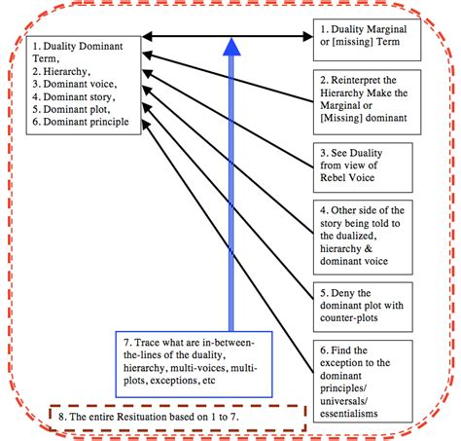
Figure 2: Boje’s Narrative Deconstruction Method

Deconstruct this UN Goal 14 paragraph: “The world’s oceans – their temperature, chemistry, currents and life – drive global systems that make the Earth habitable for humankind. How we manage this vital resource is essential for humanity as a whole, and to counter balance the effects of climate change” (boldness, mine).
- Dualities: Start with the word ‘oceans’. It is a duality, since all water is not ocean; it marginalizes the other sorts of water. Ocean salt water, and do not sustain life on the planet. It takes the marginalized (unstated term) freshwater’ to sustain life. Another word for freshwater is ‘living water.;
- Reinterpret the Hierarchy: Deconstruct the hierarchy implied in the phrase ‘global systems’. It is another way to say, the global systems of ‘Water Capitalism’ also known as Carboniferous Capitalism, and the fact that water is being transformed form a common good for all, to a commodity traded for wealth accumulation, so that water becomes something accessible to the rich, the haves, and not the right of the have-nots. The hierarchy revealed is water commodity is higher order than common good. Another hierarchy chain to deconstruct: profit over planet, commodity over equality; rich over poor; humanity over all other species.
- Rebel Voice: Complete the deconstruction of the phrase: “global systems that make the Earth habitable for humankind.’ In #2 step, we noted there are more species existing on freshwater than just humankind. We can push the deconstruction further, and look to a rebel voice, posthumanism or ‘who speaks for non-human species? The UN Goal 14 phrase is decidedly a humancentric construction of meaning, and it carries an implied marginalization of the rebel meaning, posthumanist right of all species to exist, to have living water to sustain their life, too.
- Other Sides of the Story: We are deconstructing the UN construction of Goal 14, and revealing some other sides of the story. As William James (1907: 96) puts it “Things tell a story.” The non-human species, the other animals, all plants, insects living cells (some in our own body), are living things that tell their side of the story. Without living water nothing lives.
- Deny the Dominant Plot with Counter-Plots (or what is called ‘counternarratives and counterstories): In deconstruction the first rule is ‘every grand narrative has one or more counternarratives. And second rule is every living story has a webwork of counter living stories. The dominant plot of the UN Goal 14 Paragraph, continues with “… and to counter balance the effects of climate change”. The oceans are not the blame for climate change. Rather there is an absent other, unstated in the paragraph, the role of global ‘water capitalism’ the competition of the developed capitalism nations for the water of the less developed nations, in a water war that is brining about a global water crisis. One counternarrative, then to Goal 14, is it masks, hides, and shadows the role of water capitalism in brining about climate change. Another counternarrative is what we need to do is develop ways to measure the effect of water capitalism, not on ocean water, but on ‘peak water’ Every living thing has a ‘living story’ (but not in western ways of knowing WWOK). In Indigenous Ways of Knowing (IWOK), the counterstory to a story that water is use H2O atoms, is that water is spirit, part of spiritual ecology.
- Find the Exception to the Dominant Principles/Universals and Essentialisms: For this let us read further, and deconstruct the second paragraph:
“Over three billion people depend on marine and coastal biodiversity for their livelihoods. However, today we are seeing 30 percent of the world’s fish stocks overexploited, reaching below the level at which they can produce sustainable yields.”

In this paragraph, the dominant principle constructed in UN Goal 14: Life Below Water “world’s fish stocks overexploited, reaching below the level at which they can produce sustainable yields”. Here is one exception (there are many others), is is not only humancentric (duality), but it reduces the global water crisis of peak water to fish stocks overexploited, as if controlling that would then control.
- Trace What are In-Between the Lines of the Duality, Hierarchy, Multi-Voices, Multi-Plots, Exceptions, etc.: We will next look at the final two paragraphs in UN Goal # 14: and deconstruct the universalisms and essentialism, one by one:
“Oceans also absorb about 30 percent of the carbon dioxide produced by humans, and we are seeing a 26 percent rise in ocean acidification since the beginning of the industrial revolution. Marine pollution, an overwhelming majority of which comes from land-based sources, is reaching alarming levels, with an average of 13,000 pieces of plastic litter to be found on every square kilometer of ocean.” Here we can trace how there is a reduction of Peak Water Crisis produced by humans’ carboniferous practices (note how capitalism is omitted), which is traceable, in turn, to consequence of increasing ocean acidification since industrial revolution, which is traceable, in turn, to land-based plastic pollution.

While all this is true enough, the construction chain masks, hides, and shadows the entire peak water crisis, as if its just about plastic, and the solution is to just clean the plastic out of the ocean. It’s a narrative act of reductionism, and a sleight-of-hand to distract us from the big picture. We can now deconstruct the final paragraph:

“The SDGs aim to sustainably manage and protect marine and coastal ecosystems from pollution, as well as address the impacts of ocean acidification. Enhancing conservation and the sustainable use of ocean-based resources through international law will also help mitigate some of the challenges facing our oceans.”

Here we see a diabolical narrative grand narrative abstraction and another sleight-of-hand. The plot tells us that by protecting marine and coastal ecosystems from [human] pollution, acidification is solves, and we conserve sustainable use of ocean-based resources [note that water is now totally a resource, aka commodity] and is protectable through international law, the [peak water problem still unstated throughout] is mitigated. Diabolical! But wait! Who makes this international law? Who enforces it? For whom? Obviously UN, but also the World Bank, the International Monetary Fund, and the World Trade Organization. These are the bodies that make the international laws, and for whom: of course, not for posthumanism of all species, not for all humanity either, but for a billionaire controlled corporate giants that lobby the political system to sustain water-business-as-usual.
- The Entire Resituation based on Steps 1 to 7: Resituation is the most important part of deconstruction method, since all the other steps helped free our minds of the receive grand narrative emplotment, dualism, universals, essentialisms, and brings the sleight-of-hand into view, so we see the solutions UN Goal #14 is constructed to mask, hide, and keep in the shadows. By now you are aware that Peak Water is the last throes of Water Capitalism, after Carboniferous Capitalism, takes its last gasp. The solution is apparent, we have to stop Water Capitalism from turning living water into dead water by making water a commodity managed by international law for the benefit of a few human animals that happen to be quite rich and powerful, their giant water corporations, even though living water is being turned into dead water, and it means the Sixth Extinction of most of life, most of humanity too (Boje, in press There is No Planet B).
It all spells, ‘Water capitalism’, water being bought and sold like oil and gas, beer or any other commodity. I shall argue that water is alive, and quite the spiritual being, and we need to declare water a person with unalienable rights of existence, not a commodity for sale in ‘water capitalism’ (Byatt, 2004; Osborne, 2008; Ahlers & Zwarteveen, 2009; McDonald, 2009: 4; Block & Nelson, 2015).
Next, we can deconstruct the pictorial narrative-image of ‘life below water’ is a young ‘native’ girl swimming under water to collect sea life. Please deconstruct the picture, for its implicit narrative.
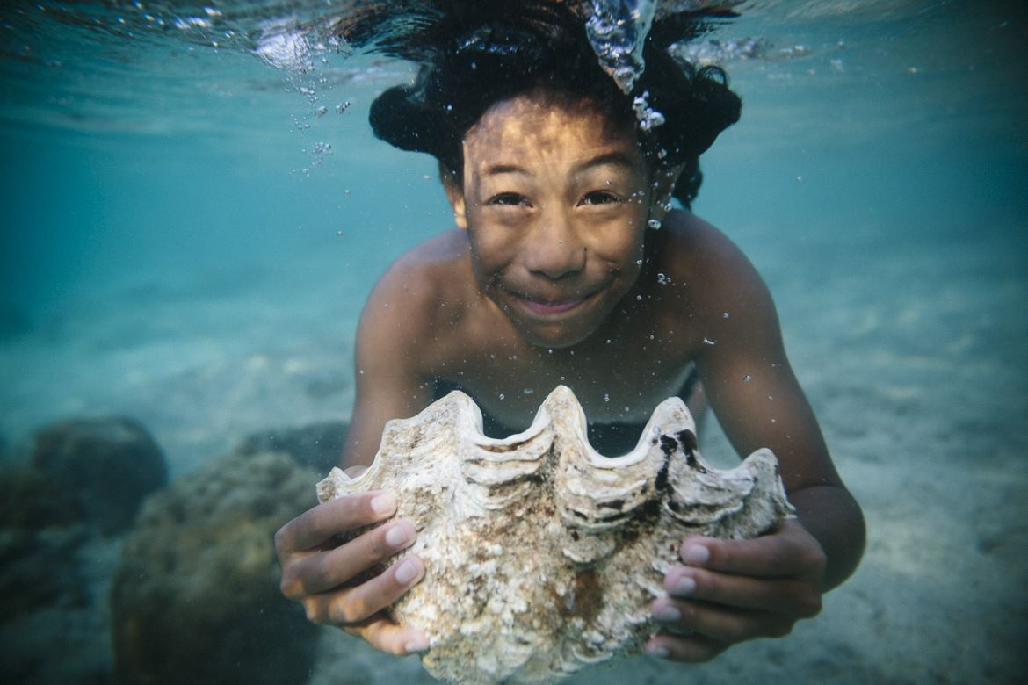
Figure 3: A Photo Tells a Narrative Construction of the Peak Water Crisis, if you take the time to Deconstruct it
How does this narrative-pictorial answer the ‘who question’ of who is the life below water? (Source: IBID). Take it through the eight-deconstruction steps. Identify the dualities, the hierarchies, the exceptions, etc. in the narrative picture. Here are some hints. It’s not just any girl, but a non-white, non-Western girl. She is swimming, as if in swimming pool of freshwater, but without the chlorine. She dives just below the surface to pull up a giant clamshell, as she expels her breath. The untold side of the story, what Linda Hitchin (2014) calls the ‘untold story’ is being masked, hidden, out-of-sight.
Beneath the several UN Goal 14 paragraphs, and the photo, are six factoids, each of which merits deconstruction. Let’s look at the sixth one.
“US$3 trillion Globally, the market value of marine and coastal resources and industries is estimated at US$3 trillion per year, about 5 percent of global GDP” (boldness mine). This sums it up, and it deconstructs the entire UN webpage. The duality revealed, it is about US dollars, US$3 trillion in global market value, of marine and coastal resources and industries. This is a manifestation of what is known as the ‘Triple Bottom Line’” narrative (Boje, in press). Here are some images I use to deconstruct it.

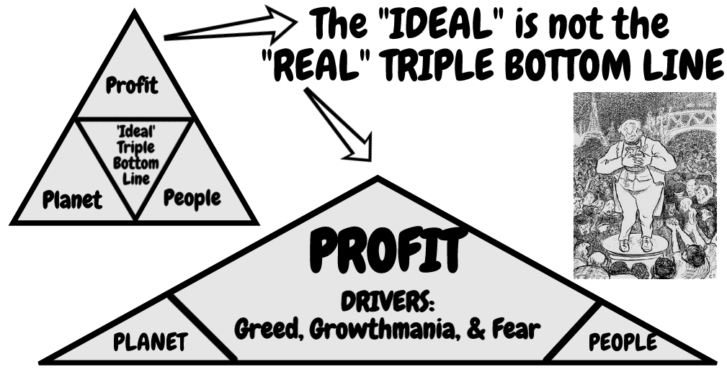
Figure 4: Triple Bottom Line Redrawn (Source Boje, in press)
At left is the usual ideal narrative-image is redrawn with the actual proportions of the UN Goal 14 grand narrative ‘Life Below Water.’ At right, is the Profit bottom line, and it looms quite large and the unstated drivers are greed, growthmania, and fear. Planet and People are barely even visible, as bottom lines. This next figure is my own rendition of ‘Quadruple Bottom Line’ that includes the Sixth Extinction (Boje, in press):
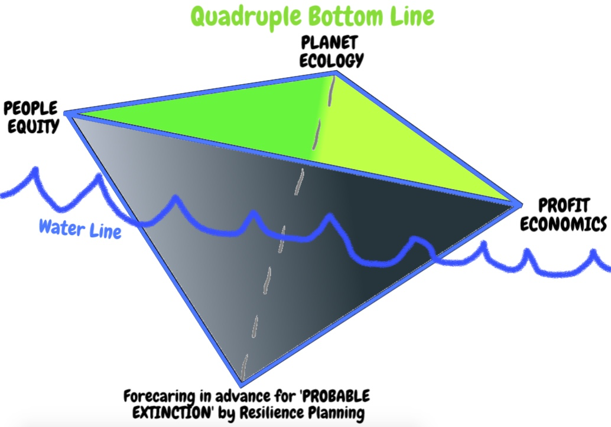
Figure 5: the Quadruple Bottom Lin of Probable Sixth Extinction (Boje, in press).
The solution to the Quadruple Bottom Line is self-evident counternarrative: We need forecaring in advance for the ‘probable extinction’ (#6) that we are already in, has already begun, and is claiming life at rates never seen on earth since the Big Bang.
The ‘true stroytelling’ problem, as you might suspect, is that the UN has bought into a humancentric narrative, and is hiding the peak water reality of Sixth Extinction from view, blaming pollution, as if that is the total storal. It is a false telling, instead of caring for all species affected by climate change it reduces all to a tale of young girl swimming for clamshell. Meanwhile freshwater is being treated as a resource, a commodity for human consumption and production, something traded to the highest bidders on commodity markets. Here is a short list of while it is true on one hand it is false storytelling on the other hand:
- While it is true that three billion people depend on marine and costly biodiversity for the economic livelihoods, water has a much wider role in the viability of all life. This essay is looking critically at UN SDG Goal 14 ‘Life Below Water’ because we believe it need narrative deconstruction (Boje, 2001). Goal 14 is Profit-, and People-centric, and misses ways ‘all life is already under water, living in water.’ The Goal 14 narrative plot begins this way: The health of our oceans, lakes, rivers, and groundwater is linked to the legitimizing narratives about our collective future. While water covers 70% of earth’s surface and of that 97% is oceanic salt water, and 2% is glacial ice, it is the final 1% that is life-giving water that by sun, soil, and natural magnetic fields gives us living water that animates, amplifies, and aerates all life on earth. Water is a living substance, which when treated poorly by humans’ production, distributions, and consumption practices becomes ‘dead water.’
- While it is true the 30% of the world’s fish stocks are overexploited, and below that UN target level, fish industries cannot produce sustainable yields, there is more going with what is ‘life below water.’ Let’s look at how the narrative uses basic facts to reduce its emplotment to humancentric instead of posthumanist plotline:
- While it is true that there has been a 26% rise in ocean acidification of the oceans since the dawn of the industrial revolution, there is more the water than its being polluted by land-based production and consumption of plastic, such as 13,000 pieces of plastic that litter every square kilometer of our oceans.
- While it is true that the ocean contains some 200,000 identified species living under water, there is much more life living in water, on the orders of trillions of living microorganisms.

In sum, the UN SDG #14 ‘Life below water’ focuses on ‘profit’ bottom line (US $3 trillion value of marine and coastal resources and their industries per year, as 5% of global GDP), the ‘people’ bottom line, and misses the the fact that life that the ‘planet’ is water life, that is being commodified.
To explore the ‘who question’ we must get some idea of ‘what is water’. What is water asks Jamie Linton (2010). Let’s look at bottled water; keeping in min it is by far, not the biggest water problem. Rather it’s only a part of the non-renewability of the water cycle, once the natural aquifers and freshwater systems are depleted past the point of water ecological renewal.
Bottled Water is Dead Water The FDA does not require water distributors reveal the source, content, or processing method. Oftentimes people buy ‘dead water.’ Living water is more that H2O. Living water has magnesium and calcium minerals necessary to your body life. “Did you know that bottle water is no safer than tap water?” And often, bottled water, according to the EPA and EWG is actually inferior to tap water.
“Bottled water is not an answer to the search for drinking water free of chemical pollutants” (ENG, IBID).

A true storytelling inquiry reveals that bottled water is only part of the story of ‘dead water’. My purpose here is a true storytelling of the UN SDG Goal 14: ‘Life Below Water.’ The quick answer is ‘living water’ is becoming ‘dead water’, and its not just about life below the ocean water, nor is it just plastic bottled water, and its pollution by plastic and heavy metals, and waste products. Rather, the true storytelling is about first, how ‘peak water’ capitalism is already past its prime, and what is exhausting life on the entire planet, is the non-renewability of ‘living water’ and how the planet is becoming totally ‘dead water.’ Second, it is about how minerals such as magnesium and calcium are being filtered out of bottled water by the water corporations and out of tap water by municipalities, around the world. It may well be that filtering our rainwater is safer and healthier.
Turning to the second problem: how ‘living water’ is turned into ‘dead water’, because essential minerals are being filtered out, while petrochemical solvents and other contaminant pollutants are being added in. Good minerals includes magnesium is important to over 300 biochemical reactions in the body. Magnesium is necessary to 50 to 60% of bones and soft tissues, without a sufficent amount men get hip fractures, everyone gets unhealthy nervous and immune systems. Without the right amount of magnesium diabetes, blood pressure, and heart do not function properly. Calcium gives structure to bones and deity, helps nerve cells to communicate, makes our muscles move, and releases hormones and enzymes. Calcium also helps blood to circulate.
Bad chemical pollutants include Trihalomethanes (THMs), when halogen atoms replace three of four hydrogen atoms of methane. THMs are byproducts of adding chlorine to disinfect drinking of tap and bottled water. The skin absorbs THMs when showing, bathing or swimming in chlorinated pools. THMs were the subject of the first drinking water regulation act in US in 1974. THMs are a known carcinogen and affect reproduction, depression, plus other health hazards. Take for example, on of the more prevalent THMs, chloroform. It causes depression of central nervous system, and in larger amounts, produces deep coma, and is lethal at dose of 1.6 oz. Once used as an anesthetic, it was discontinued, due to liver degeneration, liver tumors, and lots of death cases. Another example is Dupont’s Fluoroform (aka fluoromethane), a chemical compound used in the semiconductor industry to etch silicon, and as a refrigerant. It is among the most potent greenhouse gases. One ton of it has same effect as 11,700 tons of carbon dioxide. It stays in the global warming atmosphere for 270 years.
In sum, THMs are in tap water and bottled water, causing cancer, reproductive issues, high blood THM levels, and so to me, THMs are the epitome of ‘deadly water.’ Pre- and post ratios of THM exposure was found to be 5 to 15 times more from showering than drinking the tap or bottled water (which is mostly tap water).
Time to deconstruct Goal 14’ TINA narrative ‘There Is No Alternative’ (TINA) is a phrase made popular by Margaret Thatcher, as she sidestepped her critics, to implement neoliberal economic policies. We call this the ‘TINA narrative’. Fast forward to the last years of “Carboniferous Capitalism” (a phrase popularized by sociologist, Lewis Mumford (1934/2010: 156) the movement toward burning fossil fuels (coal, then gas & oil) to power industry is creating ‘dead water’ systems:

“The great shift in population and industry that took place in the eighteenth century was due to the introduction of coal as a source of mechanical power, to the use of new means of making that power effective--the steam engine--and to new methods of smelting and working up iron. Out of this coal and iron complex, a new civilization developed.”

Carboniferous Capitalism legitimates ‘business-as-usual’ strategy and policy, and prevents alternative ‘living water’ futures from being considered. Here, we will focus on ‘dead water’ how the world’s oceans, lakes, rivers, and underground water are being polluted, and ‘living water’ to animate and sustain life is becoming scarcer and scarcer. We will propose a counternarrative to the TINA narrative of ‘Dead Water Capitalism’, which turns water into a commodity, is to treat water as for the common good of all species. The counternarrative is called ‘living water’ because ‘all life is under water’ and ‘all life exists in water.’ The human body is a walking climatic ecosystem of 37.2 trillion living cells, each of which exists in water, or not at all. Those cells need water at an ideal PH of 7.35 and needs the magnesium, calcium and other micro and macro trace minerals, and the slight electric charge water carries.
“Peak water”is defined by Peter Gleick and Meena Palaniappan (2010) in a peer-reviewed article in the Proceedings of the National Academy of Sciences. At the peak of the bell shaped ‘peak water’ curve, half of the quality water is depleted, and is maximum cost-effective extraction of surface and ground water. As the peak falls away, what freshwater remains is quite costly or impossible to obtain with existing technologies. Desalination is costly, and deep underground water too costly to pump to the surface. New dams and reservoirs are costly to create. Transportation of water from place to place is costly. When the backstop lime of freshwater is reached, a point is reached when not only is freshwater scarce, alternatives are unavailable.

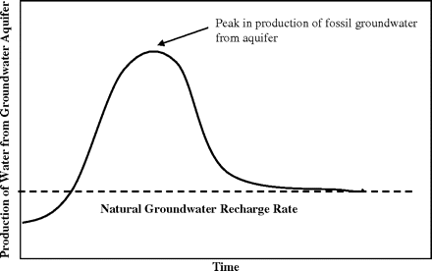
Figure 6: Theoretical Peak Water Curve of Water Extraction from Natural Groundwater Aquifer and Recharge Rate (source).
Living water overuse is causing sercious and irreversible ecological deamage. Living water cannot sustain human, other animal, plant, or marine life if there is irreversible ecological damage from commercial, industrial, and other human activity. The earth’s groundwater aquifers, have slow-recharge rates, and are becoming nonrenewable by their escalating depletion. Planet Earth has a total of 1.4 cubic kilometers of water, which sounds like a lot, but 97% of which is surface oceanic salt water, and that means the freshwater stocks are only about 35 million cubic kilometers, of which 2% is locked in glaciers, and about 1% remains as accessible freshwater in river flows and accessible groundwater aquifers. With the rapid onset of ‘peak water’ fresh water stocks are becoming depleted, and with climate change weather disruptions. But an even worse problems is much of the water renewal is disrupted and becoming exhausted, and all life just does not come back from that extinction event. Our point is many uses of living (or fresh) water are non-consumptive, meaning lost to the hydrologic cycle or to future use, because they are not recycled by natural systems. “Consumptive use of water typically refers to uses that make that water unavailable for immediate or short-term reuse within the same watershed” (Gleick & Palaniappan, 2010). When water is not replaced in aquifers and watersheds, then it is unavailable for reuse., and what remains is heavily contaminated, non-renewed. It remains in the hydrologic cycle, as H2O, but its non-consumptive, a depleted substance, with zero life energy, or a pollutant substance.
The solution to peak water is to get control of our ‘Water capitalism practices’. We need to manage the renewable flows of rainfall, rivers, stream, and groundwater basics so they recharge in relatively short time frames. This is called stochastic hydrology, recharging the water source energy, instead of exhausting renewable water capacity of the entire planet. There are at least two peak water limits. The first peak water limit is exhausting the easily less costly available supply, and the second peak water limit is exhausting the renewable stochastic hydrology cycle so fresh water is not replenished at optimum level. In other water the planet’s living water renewability becomes dead water.
For example, here and now, in New Mexico, when the Rio Grande River flows fall to zero, it is not a perennial living water renewable system, not just from being H2O but from having the chemical balances that are life sustaining. When New Mexico’s groundwater aquifers are depleted, then the remaining water there is nonrenewable, inaccessible, from being overpumped to point of exhaustion. Recharge rates matters. Overpumping matters. The aquifer levels along the Rio Grande River renewability matters. And this is precisely where UN SDG Goal 14 “life below water” is missing the point: what matters is ‘living water renewability’, so all water does not become ‘dead water.’ The slower the renewability of freshwater, the quick the extinction of all species, because none can live on contaminate industrial wastewater. Once peak ecological water is reached, due to appropriation of water by humans, then there is also loss of water to sustain plants, trees, animals, marine life, and the ecosystems of the entire world collapse, one by one, than altogether. Freshwater (aka ‘living water’) is fundamental to life on the planet. The United States is already past its renewable peak water limit, and its industrial and household practices are in the main, unsustainable. The western capitalism wolrd is extracting the water, appropriating the water rights of the developing world, commodifying water, degrading those water sources, making water there too costly for indigenous ‘living water’ access.
At a macro-water level, earth’s surface constitutes 75% of the planetary surface, and yes, it is becoming polluted at an accelerating rate by human industry and consumption habits (Boje, in press There is No Planet B). Our oceans, lakes, streams, and rivers are become floating garbage patches. Marine vertebrates have decline by 49% between 1970 and 2012. But this UN goal 14 narrative is too reductionistic, and is missing the existence of micro-life, that swims in water of all organic life, all our living cells. The goal is too humancentric, and misses how all life, not just fish, etc., is existent, in water.
Without water life on the planet would not exist. Water is the only substance on the planet that can exist in three states, ice-solid , running liquid, and gaseous. Water has unusual chemical physical properties compared to other liquids. Water’s density becomes less below freezing (it expands). Pounding wooden wedges into cracks in stone, the water sells the wood and the rock severs. Water has many other anomalies.
Life Below Water is ‘Water Memory’ the ability of water itself to self-organize its structures molecularly to make sense of its surroundings. According to Nobel Prize laureate Luc Montagnier (and colleagues, 2015), water has memory. Water memory is a trace of substances surrounding and dissolved or transported in it. Water records information, taking on new properties. Water memory is the structure of the molecules of water, and is more important than its structuration chemical composition. When you turn on the lights the water is change electromagnetically; its structure changes. Water reacts to any irritations. 440,000 information panels, react to its environment. The stability of water cluster structures, is what is doing the water memory of information. The molecular structure of water is its alphabet out of which memory is recorded. The water’s memory changes, and when people drink the water, they change.
Professor Masaru Emoto’s (2008, 2011) experiment of people projecting various emotions on water. Water has a memory capability all its own. Water impressions are tested by freezing it in a cryogenic chamber, and the water structures (crystal patterns) are attained. Structuralized water memory makes vegetables grow stronger plants. 20% less structuralized water is needed for irrigating corps. Fish introduced into water treated with Dr. Emoto’s water imprinting show phenotype changes compared to untreated fish. Footnote Water has memory accessed Nov 6 2018 at https://www.youtube.com/watch?v=FMrQme-DEas
Here are some images of Dr. Masaru Emoto’s experiments of imprinting water memory.

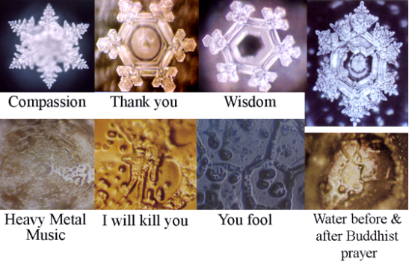
Figure 4: Frozen Water Structuration after Human Inention
Crystals of tap water look like a chaotic confused spidery. Water infused with positive intent, has the structure of symmetrical six pointed star. The hypothesis is that our observation intent to the water changes its memory structure.
We Humans are Life Below and In Water Our bodies are composed of water memory structures. The water we drink is composed of water memory structures of their journey to us. Therefore, the hypothesis is that our thoughts of healthy, happy, and terrific affect the water memory of our bodies. People separated by huge distances are able to synchronize information transmisison waves during their meditations, as measured by brain scan.
We drink 2.5 liters of water a day and absorb another 1.5 liters of water in bathing or showering. Natural structure of the water in set of pipes with many right angle turns is devitalized and sucks energy structuralization out of it. Compare to nature’s water that flows in small curves, is vitalized, structuralized. Infrastructure delivery of water matters. We pollute water, as it adopts our stress and malice in its journey to your tap.
One hypothesis is the electromagnetic field of the human heart, affects the water electromagnetic field and its structuralization of blood pumped through the body. In Venezuela there is a plateau of water previously untouched by humans.This water exists only on one place on earth, in Venezuela. 3.5 million years ago shifts in the tectonic plates occurred, forming elevated plateaus (pillars).
The local Indian tribe exists downstream from this water. Water from this source has a different structuralization cluster pattern than our industrialized water systems. For the Pemon Indians of Venezuela's Gran Sabana region the tepuis - the taple-top mountains rise dramatically out of the jungle and the savannah . They believed these to be the abodes of gods or spirits.
The water structure of each person’s water memory is exact duplicate of the water in the place where we were born and grew up. Water assimilates the information of the local minerals. Water is different every place on the water. The water we buy in singleton’s-use plastic bottles, is dead water. Animals will drink water form a spring instead of the plastic bottled water, when given a choice.Nestle’s Aquafina, Pepsi’s Aquafina, and Coca Cola’s Dasani bottled water can be used in this experiment. These are ‘dead waters’ and our body’s electrical charge pattern changes from drinking this waters as compared to structured water whose electric charge has an aerobic environment rather than an aerobic environment.
Eastern medicine is based on the vibrations and resonance of the body’s water content. Water resonance is either strong, weak, cold, and hot. They make an energy scan of the body’s water, and apply their chants and prayers. Frequency of vibrations of prayers is 8 hertz and corresponds the harmonic structure of the earth’s magnetic field. The structuralization of water clusters of water molecules is affected by the prays, the music, then intentions given towards water.
There would be enough fresh water for all species of the planet, above and below water, if it were not from he attack of Carboniferous Capitalism that is becoming Water Capitalism. The commodification of water change its memory structure. It is predicted that water will become the source in international conflict in the 21st century. As the world runs out of drinkable water, life below water will cease, as will life on land. We have lost half the plankton in the ocean. In past 30 years the destructive force of hurricanes has doubled. 4 million people have died in natural disasters in the past 3- years. 4.5 billion people were affected by these disasters (such as becoming homeless, having to migrate, etc.). This increase in disasters is an outcome of human activity. The fear that grips everyone is affecting the pollution of the water, and the impression of water memory and all that is happening around us.
Water is the medium through which all nature lives and is governed. Life on earth began in the oceans and we start our life in amnionic fluid that is 99% water. Water has unexpected properties according to water memory theory. Water retains the memory of the molecules properties that it encounters. Notion of water memory is controversial. He detects electomagnetic singles in patients infected with HIV. This suggested water memory, to Luc Montagnier (virologist). He is working on a rad hot issue. Water memory can open a new area for medical research. Water memory theory casts new light on potential properties of water. He detects electromagnetic waves in DNA. DNA carries genetic information of each organism. DNA molecules are added to sterile water solution, to achieve higher and higher dilution. The electromagnetic signals are collected on each of the sample tubes with dilution of DNA and 10 control tubes of only water. Classical physics of molecular biology predicts no difference between the DNA dilute solutions and the control group of samples. The electromagnetic signals are water memory of their encounter. Water can receive and transmit signal. Water signal from France is sent to Italy, where its electromagnetic signal is digitally played for one hour to a sterile sample of water, and tested to see if there is water memory. Water has listed to the DNA virus digital music in a DNA (PCR) testing procedure used in criminology to test for DNA matter being reconstituted. If little black bands appear on screen, then the PCR test is a success. This is a long distance duplication test.
If we mix aged water (with memory) and mix it with new rainwater, what are the results. In Taiwan, there is research on stabilizing water, with aged water, for use in fish and shrimp farming aquaculture. Quantum physics has never been integrated by biologists or chemists. Autism establishment contested Luc Monagnier memory work findings. Anti-infectuous drugs were applied to counter the microbes in the blood of autism patients. Signals story in water memory in their contact with pathogenic molecules. Luc Montagniew eventually hopes to treat cancer with electromagnetic waves (simulating the waves of various medicines, without injecting the medicine). The scientific community is opposed to this approach. More so the pharmaceutical industry, who with digital biology, would no longer have a market to sell its pharmaceuticals. The body makes no distinction between a digital signal and the pharmaceutical signal, use as a recorded voice wave is not distinguishable form a live persons voice signals. Our body is made of 99% water substance, and 1% other kinds of molecules, in microscope so small that it is quantum physics nanoscale. To understand how a water cell works you must do quantum physics, where wave/particle duality operates.
There is an overabundance of water in the earth’s mantle, and is part of volcanic eruption activity. We live in a soggy-water universe, with water (ice) found on Mars, and on Venus. Water at the micro level, there are ionic bonds, such as when sodium chloride (salt) is dissolved in water. Evaporating the wort leaves the salt molecules. Positive and negative charges of the H2O are attracted to each other. Since water has positive and negative parts, it is polar and grabs on to the NaCl ions. With sugar, C12H22O11, the molecules moves around, sugar dissolves. There are chemical reactions in our body due to water (as solvent, metabolism heat capacity, and coolness).
Water is life and gives life Water is an essential element of life. Water touches every element of life. Complex systems and technologies channel water throughout an empire. Chlorine was added to water to eliminate water born diseases. The water infrastructure is 30 times length of our highway system. Clean water act and safe drinking water act protect our safety. Water’s unseen pipes and infrastructure deteriorates with age, and fails. Water is three times capital intensive than and other utility. 260 gallons a day of water consumed per American.
Conclusions
Living water is an essential element of all life Living water and dead water touches every element of life on earth. Complex systems and technologies channel water throughout a growing water empire. Chlorine is added to water to eliminate water born diseases, but carries a number of THM risks, by producing chloroform, bromoform, brondichloomethane, and chlordibromomethane. The ‘dead water’ infrastructure is third times length of our highway system, and growing. The 1974 US clean water act and safe drinking water act no longer protects our health and safety. Water’s unseen pipes and infrastructure deteriorates with age, and fails. The chlorination and fluoridation water treatment of tap water and bottled (& flavored) water is increasingly problematic. Water is getting more expensive each year. Water is three times capital intensive than and other utility. 260 gallons a day of water consumed per American. As we slide down the Peak Water curve, we have entered a downward spiral of ‘living water’ shortages and increases in THM health risks.
The UN Goal 14: Life Below Water, is well-intended, yet when deconstructed, there is much yet to be done to address the global water crisis. The solution is obvious. We need to stop the greed, gluttony, and growthmania of water capitalism. Treating ‘living water’ as a commodity in market capitalism hastens and deepens the impact of the Sixth Extinction (Boje, in press).

References
Ahlers, R., & Zwarteveen, M. (2009). The water question in feminism: water control and gender inequities in a neo-liberal era. Gender, Place and Culture, 16(4), 409-426.

Block, W. E., & Nelson, P. L. (2015). Water Capitalism: The Case for Privatizing Oceans, Rivers, Lakes, and Aquifers. Lexington Books.

Boje, D. M. (2001). Narrative Methods for Organization and Communication Research. London: Sage.
Boje, David M. (in press). Storytelling in the Global Age: There is No Planet B. Singapore: World Scientific Publishing Co. Pte. Ltd.

Boje, D. M.; Larsen, Jens; Brunn, Lena. (2017). ‘True Storytelling. How to succeed with your implementation’, working paper. http://oldfriendsindustries.com/?page_id=1048 Emoto, M. (2008). The healing power of water. Hay House, Inc.

Byatt, Ian. (2004). Managing water for the Future: The Case of England and Wales. Pp. 73-88 in Julie Trottier and Paul Slack (Eds.) Managing Water Resources Past and Present: The Linacre Lectures 2002. NY/London: Oxford University Press.

Emoto, M. (2011). The hidden messages in water. NY: Simon and Schuster.

Gleick, Peter; Palaniappan, Meena.(2010). Peak water limits to freshwater withdrawal and use. Proceedings of the National Academy of Sciences of the United States of America. Accessed Nov 11 2018 at http://www.pnas.org/content/107/25/11155
Hitchin, L. (2014). Method and Story Fragments. Pp. 213-238 in Izak, M., Hitchin, L., & Anderson, D. (Eds.). (2014). Untold stories in organizations. London: Routledge.
Linton, Jamie. (2010). What is Water?: The History of a Modern Abstraction. Vancouver/Toronto: UBC Press.

McDonald, Colin. (2014). Rio Grande: River that never runs free. Rivard Report, San Antonio. Sep 27, accessed Oct 17 2018 at https://therivardreport.com/rio-grande-story/

Montagnier, L., Del Giu Montagnier, Montagnier,dice, E., Aïssa, J., Lavallee, C., Motschwiller, S., Capolupo, A., ... & Vitiello, G. (2015). Transduction of DNA information through water and electromagnetic waves. Electromagnetic biology and medicine, 34(2), 106-112. Accessed Nov 9 2018 at https://arxiv.org/pdf/1501.01620.pdf

Osborne, Ian. (2008). Regulators are drivers of sustainable growth. Utility Week, Vol 28 (23): 13-22.

MORE INFO ON WATER IS LIFE
The Impossible Rice Experiment https://www.youtube.com/watch?v=zvShgttIq7I It is a replication of Dr Masaru Emoto’s water experiments. Water exposed to positive speech and thoughts gives health and happy and terrific crystal formations. Here is another experiment o

Breakthrough Water Research the Deep State is Covering Up - Masaru Emoto Part3 https://www.youtube.com/watch?v=Skg3lO1wtxk Gives history of Jacques Benveniste (1935-2004) water memory experiments and the reaction of the scientific establishment

Here is another on Dr Masaru EMoto’s water experiment - words are alive! https://www.youtube.com/watch?v=au4qx_l8KEU

Water has Memory https://www.youtube.com/watch?v=FMrQme-DEas

Water Memory (2014) documentary about Nobel Prize winner doing water memory experiments by Luc Montagnier https://www.youtube.com/watch?v=R8VyUsVOic0

The Memory of Water https://www.youtube.com/watch?v=ILSyt_Hhbjg Each individual produces different images from a drop of water, from the same water source. Images change when various items are placed in the water (Put a Sweet William Flower in a glass). Water memory changes our whole experience of the world, depending upon our water source (as they drink all that information storehouse).

Water Has Memory - Sadhguru at IIT Madras (Part V). https://www.youtube.com/watch?v=6C1p4HUHlfE This is about India, and how to rearrange the underlying chemical structure arrangement of water and the well being or its opposite that will come to you. Earth, Water, Fire, and Space are for him the 5 elements of Nature, our body, and our whole universe.

The Mystery of Water - What we know is a drop https://www.youtube.com/watch?v=KN3PBFxV3Xw Water has a memory changes our own understanding of the world. Water is a bearer of secrets. Water expands as it freezes unlike other substances. Shows experiment of broken pipes half way through the video, and how they reduced iron corrosion through water revitalization.

Here is a Ted Talk by Dr. Gerald Pollack https://www.youtube.com/watch?v=i-T7tCMUDXU

Can you drink rainwater? By Anne Marie Helmenstine, Nov 4 2018 Tohuthtco.com accessed Nov 12 2018 at https://www.thoughtco.com/can-you-drink-rain-water-609422; and https://www.youtube.com/watch?v=D2tD7eVeFxA accessed same day
Rainwater – Is it Safe to Drink? YouTube accessed Nov 12 2018 at https://www.youtube.com/watch?v=PwJwj-iqjMA He uses some bleach in water harvesting off grid filtration (Whole House poly cartridge by DuPont, cost about $21 each) in rainwater that sits for a long time.
7 health benefits of eating cucumber. Healthline.com accessed Nov 12 2018 at https://www.healthline.com/nutrition/7-health-benefits-of-cucumber#section2; See livesicence.com Cucumbers: Health benefits and nutrition facts, by Jessie Szalay, May 12 2017, accessed Nov 12 2018 at https://www.livescience.com/51000-cucumber-nutrition.html; See The Free Range Life. 12 benefits of cucumber water; A healthy way to stay hydrated, by Sarah (no last name), accessed Nov 12 2018 at https://thefreerangelife.com/benefits-of-cucumber-water/
Accessed at UN website Goal 13 Life Below Water, Nov 9 2018 at : http://www.undp.org/content/undp/en/home/sustainable-development-goals/goal-14-life-below-water.html
http://www.undp.org/content/undp/en/home/sustainable-development-goals/goal-14-life-below-water.html
The truth about bottled water by Dr. Wolfson, Jan 27 2017, accessed Nov 11 2018 at https://www.thedrswolfson.com/truth-bottled-water/
EWG Bottled Water Quality Investigation, 10 major brands, 38 pollutants. Oct 15 2008 accessed Mov 12 2018 at https://www.ewg.org/research/bottled-water-quality-investigation/test-results-chemicals-bottled-water
Reducing or eliminating trihalomethanes (THMs) in drinking water. THMs Accessed Nov 12, 2018 at https://www.novascotia.ca/nse/water/thm.asp And EPA Health perspectives, accessed Nov 12 2018 at https://www.ncbi.nlm.nih.gov/pmc/articles/PMC1257669/
IBID, http://www.pnas.org/content/107/25/11155

